MWOA Central/NW Section Meeting
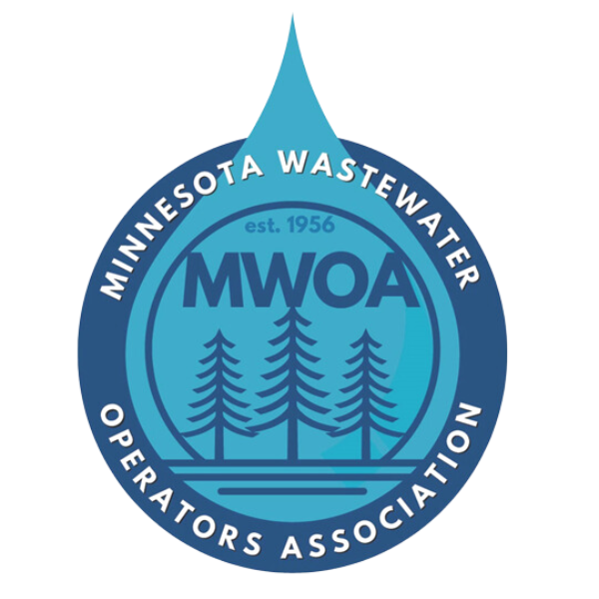
Holiday Inn Lakefront and Event room
1155 US-10, Detroit Lakes, MN 56501
Monday and Tuesday, October 5 and 6, 2026

AGENDA: (Tentative 8 Hours)

Monday October 5th

11:15 – 12:00 Registration and Welcome at HOLIDAY INN EVENT ROOM

11:45– 12:15 Lunch and Networking – (Included w/registration)

12:15 –1:00 CMAR Delivery in Wastewater (& Water)
Mac Graupman – Bolton & Menk

1:00 – 2:00 Sulfates, Nitrogen, and PFAS (MPCA Updates)
Pam Rodewad, Brian Fitzpatrick, Others – MPCA

2:00 – 2:15 Break

2:15 – 3:00 Odor Control
Apex Engineering Group

3:00 – 3:45 Safety in the Workplace
Jonathan Beale–SafeAssure

3:45 – 4:30 Chemical Feed
Jeremy Bakke - Vessco

5:00 - 7:00 Cocktail Reception at Bucks Mill (microbrew)

Tuesday October 6th
7:00 – 8:00 Breakfast and Networking – (Included w/registration)

8:00 – 8:45 EMX BioCycle-D
Mark Gehring – Xylem + EnviroMix

AGENDA (continued):

8:45 – 9:30 Inflow & Infiltration, Your Results May Vary
Kelley Janes – AE2S

9:30 – 9:45 Break

9:45 – 10:45 Dual Auger Case study
Rob Bredeson – Midwest Pump Works

10:45 – 11:30 Detroit Lakes Chloride Reduction Effort
David Quast - SEH

11:30 – 12:15 Automatic Samplers: Installation & Pumping for Successful Sampling
Mark Enochs – MNX Inc.

12:15 – 12:30 Central Section Business Meeting (Boxed Lunch to Go after)

Registration Information:
Registration Fee: $40.00 – Make checks payable to MWOA
RSVP to:
Mac Graupman at mac.graupman@bolton-menk.com or call at 507-720-5490
Rob Bredeson at rbredeson@midwestpumpworks.com Or call Rob at 218-839-7705
Call the Holiday Inn Lakeside directly for room reservations at 218-847-2121

Financial contributions made by the following sponsors:
Apex Engineering Group
Bolton & Menk
Electric Pump
Midwest Pump Works
Safe Assure
Vessco

