MWOA Southwest Section Meeting
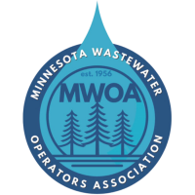
Date: Wednesday November 4, 2026
Location/Address: Windom Community Center
1750 Cottonwood Lake Dr, Windom, MN 56101
Registration Fee: $20.00
6 wastewater hours pending

Agenda:
8:00 – 8:30 Registration -Coffee & Donuts – Sponsored by Hiperline
8:30 - 8:45 Welcome – Windom Mayor Hilary Mathis
8:45 - 9:45 Industrial Pretreatment – Jaramie Logelin - MPCA
9:45 - 10:45 Lift Station Panels/Pumps and Turbine Pumps – Dan Shimota - WWGoetsch
10:45 - 11:45 Cooperative Purchasing Venture (CPV)/State Contracts – Luke Jannett – MN Dept of Admin
11:45 – 12:00 MWOA Southwest Business Meeting
12:00 - 12:30 Lunch – Sponsored by Bolton & Menk
12:30 - 1:30 Brewster SAGR Wastewater Project – Mike Carr & Miriam Martens – DGR Engineering
1:30 - 2:30 Fairmont WWTP Upgrades - John Graupman and Brian Guldan - Bolton & Menk
2:30 - 3:30 Southern MN Flooding Impacts - Paul Plaetz – MWRA & Ryan Anderson - Windom

Please RSVP to Rachel Cunningham, rachelc@newulmmn.gov by October 30.

